**DAILY ONLINE ACTIVITIES SUMMARY**

|  |  |  |  |  |  |  |  |  |
| --- | --- | --- | --- | --- | --- | --- | --- | --- |
| **Date:** | **10/06/2020** | | | | | **Name:** | **NIKHIL KUMAR** | |
| **Sem & Sec** | **4thSEM. & ‘B’ SEC.** | | | | | **USN:** | **4AL19CS400** | |
| **Online Test Summary** | | | | | | | | |
| **Subject** | | **OBJECT ORIENTED CONCEPTS** | | | | | | |
| **Max. Marks(DC)** | | **30** | | **Score** | | | **20** | |
| **Certification Course Summary** | | | | | | | | |
| **Course** | **Introduction to cyber security** | | | | | | | |
| **Certificate Provider** | | | **Greatlearning**  **Academy** | | **Duration** | | | **5.5 Hrs.** |
| **Coding Challenges** | | | | | | | | |
| **Problem Statement : Write a c program to print sum the sum of boundary elements of a matrix.**  **Problem Statement : Write a java program to find the longest repeating sequence in a string**  **String :abcdfghybdf**  **Problem statement :Write a java program to count all the triplets such that sum of two elements equals the third element.** | | | | | | | | |
| **Status:executed** | | | | | | | | |
| **Uploaded the report in Github** | | | | | **Yes** | | | |
| **If yes Repository name** | | | | | 1. <https://github.com/Nikhil401/C-Coding/blob/master/SumOfBoundry.c> 2. <https://github.com/Nikhil401/java-coding/blob/master/LongestRepeatingSequence.java> 3. <https://github.com/Nikhil401/java-coding/blob/master/SumOfTwo.java> | | | |
| **Uploaded the report in slack** | | | | | **Yes** | | | |

**Online Test Summery : Subject OBJECT ORIENTED CONCEPTS Test scheduled from 09:30 to 10:00 am. The portion for the 4th IA was 3rd and 4th module and time assigned was 30 minutes and the number of questions were 15 and each contains 2 mark.**

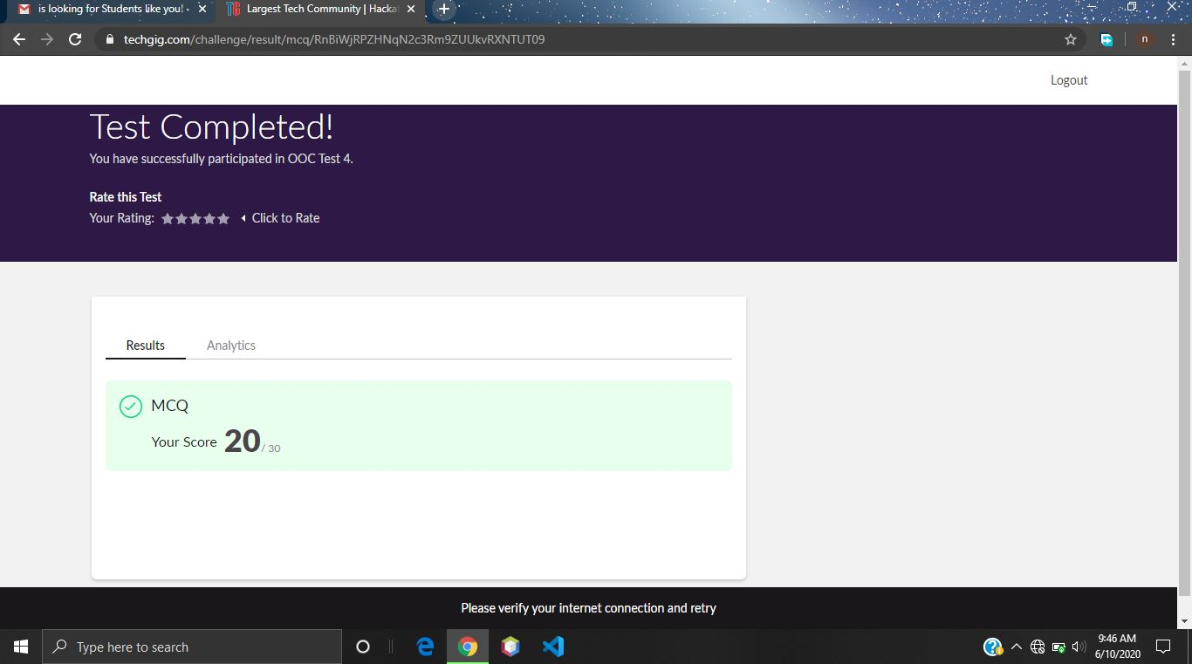

**Certification Course Summary: Today I have went through the some basic things about introduction to cryptography.**

**Snapshot is given below…**

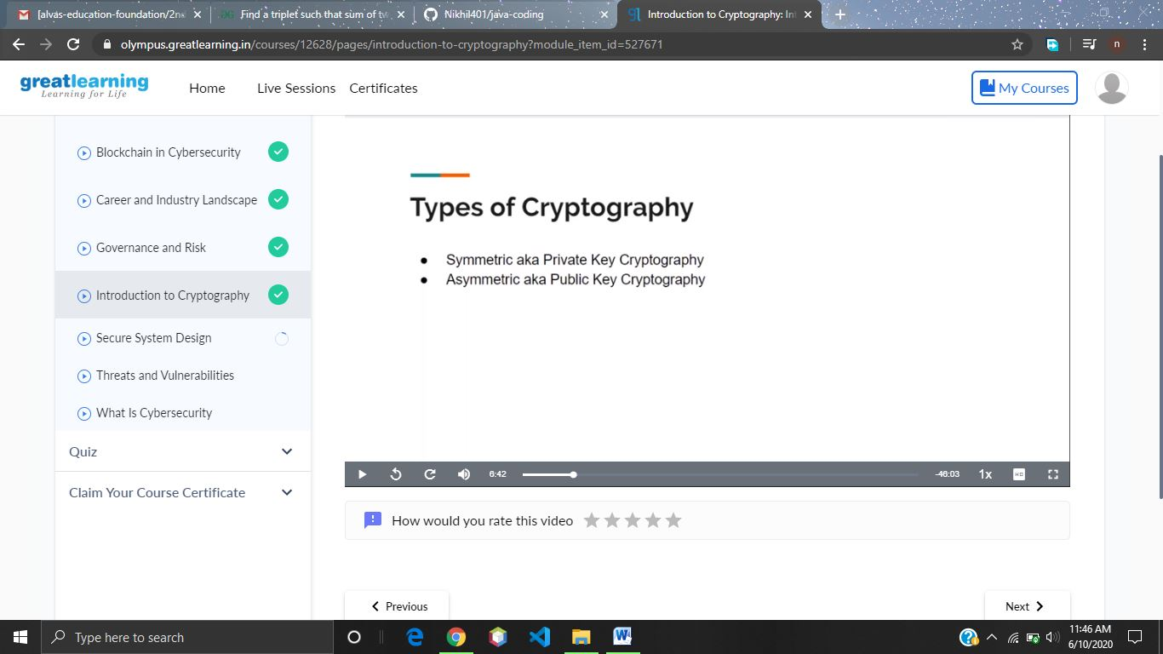

**Online Coding Summary: Today I got some coding questions from CSE Dept. The program is mentioned above(pg.01). to my GitHub repository and I’ve shared the snapshot below.**

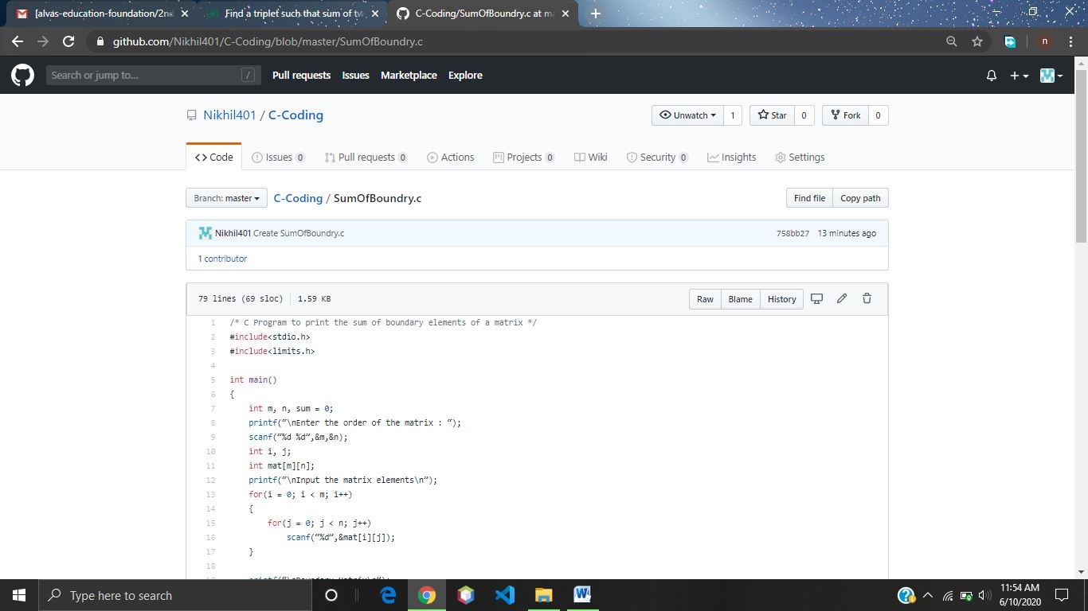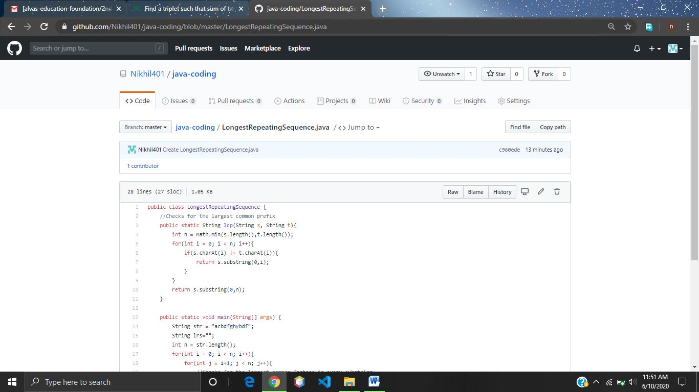

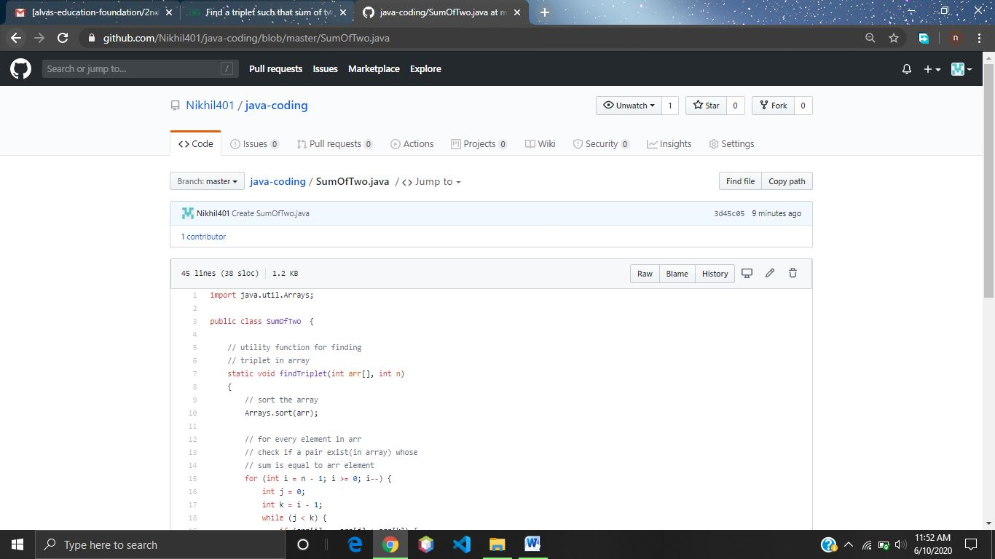**Thank you.**